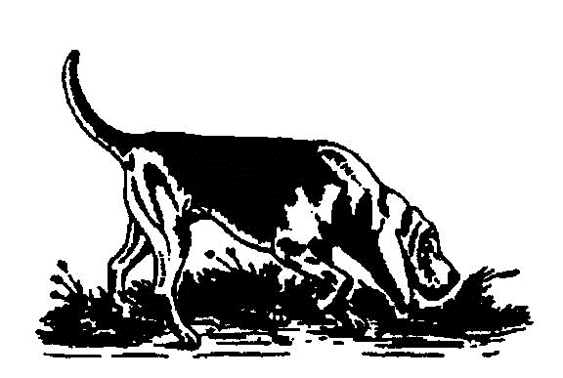
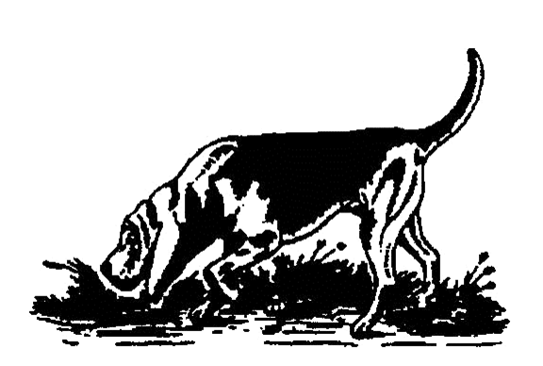
SPONSORED RIDE AT CHATSWORTH 2019
RULES AND REGULATIONS

START TIME
Start times will run from 09.00am onwards. Your start times will be available on Sunday 8th July 2019 on Four Shires Bloodhounds website / Face book page and the Sponsored Ride website.

ON THE DAY
Upon arrival, all riders MUST report to the Registration Desk. Proof of Public Liability insurance must be shown and a declaration signed (if not already provided). You will then be issued with your individual rider number, which must be worn at all times during the ride. This must be returned asap when you've finished your ride so we can reuse them.

The Route will be optional of approximately 6 or 12 miles, and cover parkland, woodland, farmland, tracks and moor land. The shorter route will be clearly marked. Marshals will be present along each route.

Please make sure you complete the sponsorship form correctly and hand in your sponsorship money on the day. Please try and raise as much as possible for this much needed charity.

In order to make the day fun, enjoyable and safe for ALL, all our riders MUST obey the Chatsworth Estate Rules. Please make sure you read the Rules carefully. Thank You.

This Ride is by kind permission of the Chatsworth Estate. Please respect their Grounds and Surrounding Countryside.

RULES:
- Entry to the Estate is via the designated entrance ONLY (see directions below).
- Respect other riders – pass CAREFULLY and SLOWLY. Warn other riders if you intend to overtake.
- It is the riders’ responsibility to ensure that their mount is sound, well shod and that their tack is in a safe condition. Hats to the Current Safety Standard must be worn at all times, and be correctly fastened.
- You MUST obey any instruction given by a Marshall or Steward.
- ABSOLUTELY NO jumping of the Cross Country Fences.
- Riders must follow the marked route AT ALL TIMES.
- No dropping of litter. Please tidy up after yourselves and take your rubbish home.
- Riders MUST park where directed by the Stewards.

DIRECTIONS:
- The only access will be via the Golden Gates, from the A619 (Baslow). This road runs between Bakewell and Chesterfield. In the event of bad weather, parking will be on the roadside.

OTHER INFORMATION:
- A hosepipe for horse drinking water will be located near the finish point.
- Numbers for Vets on Call will be posted at the registration point.
- First Aid Cover will be provided.

ABOVE ALL: Thank you for supporting our Sponsored Ride.
Have a fun and enjoyable day.
www.4shires.co.uk

